Test Case: tc002_SPX_Dev5_Crear_Requisicion_Spot_Tipo_Cobro_Project
Step 1 - Enter username and password and click to button Enter: Credentials Entered
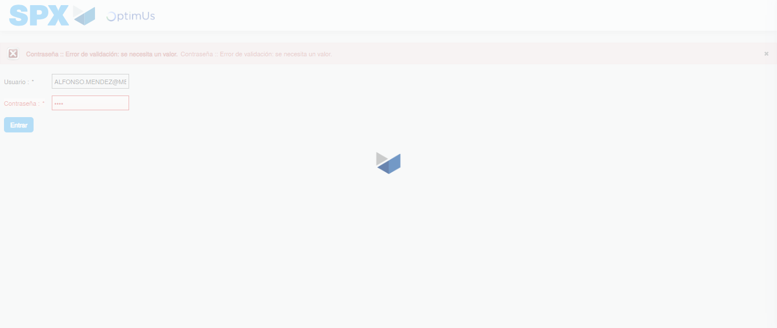Image file-name: QC_Testing-tc002_SPX_Dev5_Crear_Requisicion_Spot_Tipo_Cobro_Project-1784307231523

Step 2 - Select to UEN and Access to Spot Buy Requisitions : UEN Correctly selected and Correct access
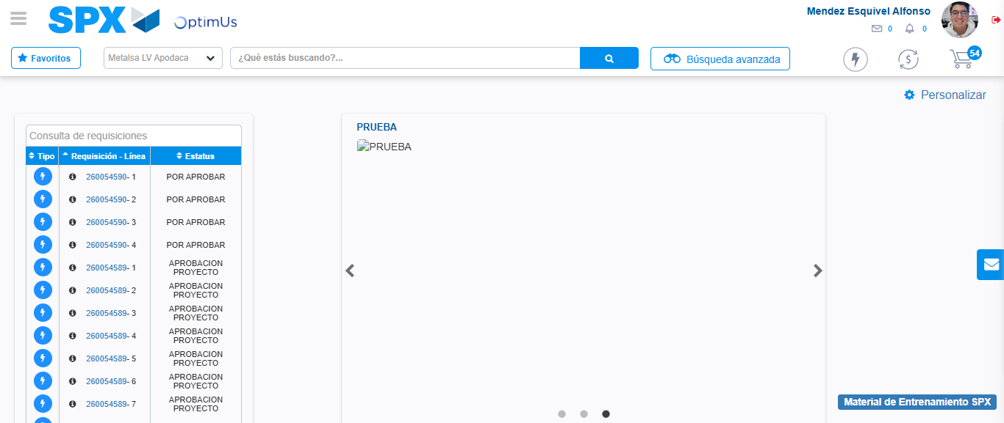Image file-name: QC_Testing-tc002_SPX_Dev5_Crear_Requisicion_Spot_Tipo_Cobro_Project-1784307312646

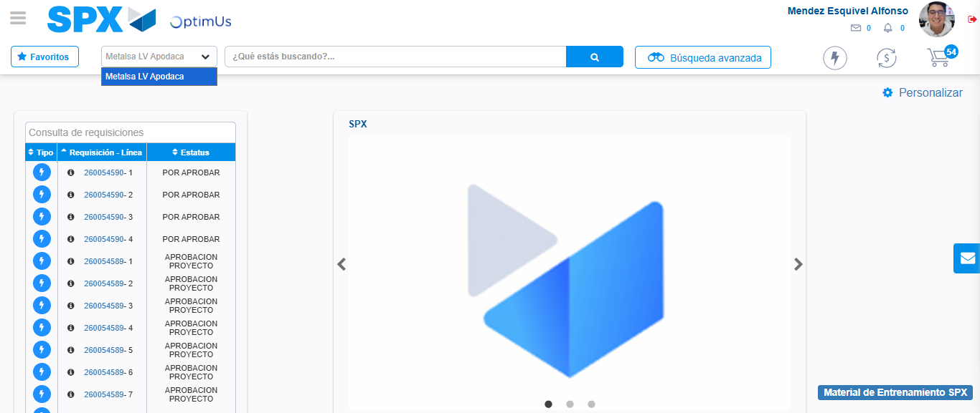Image file-name: QC_Testing-tc002_SPX_Dev5_Crear_Requisicion_Spot_Tipo_Cobro_Project-1784307315125

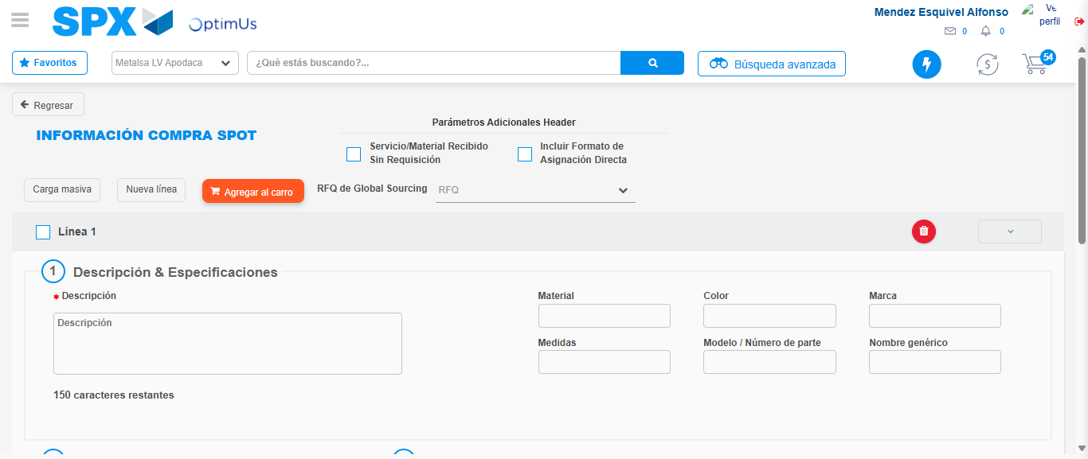Image file-name: QC_Testing-tc002_SPX_Dev5_Crear_Requisicion_Spot_Tipo_Cobro_Project-1784307326531

Step 3 - Data Capture Spot Buy Requisition: Data captured correctly
Image file-name: QC_Testing-tc002_SPX_Dev5_Crear_Requisicion_Spot_Tipo_Cobro_Project-1784307326776

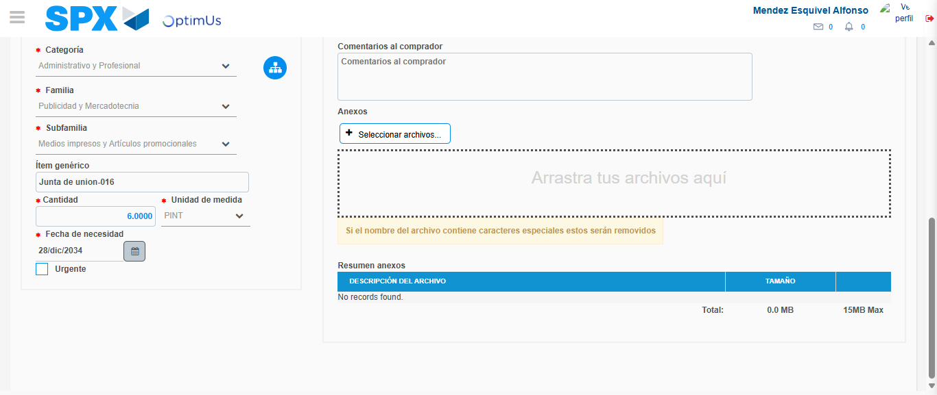Image file-name: QC_Testing-tc002_SPX_Dev5_Crear_Requisicion_Spot_Tipo_Cobro_Project-1784307337746

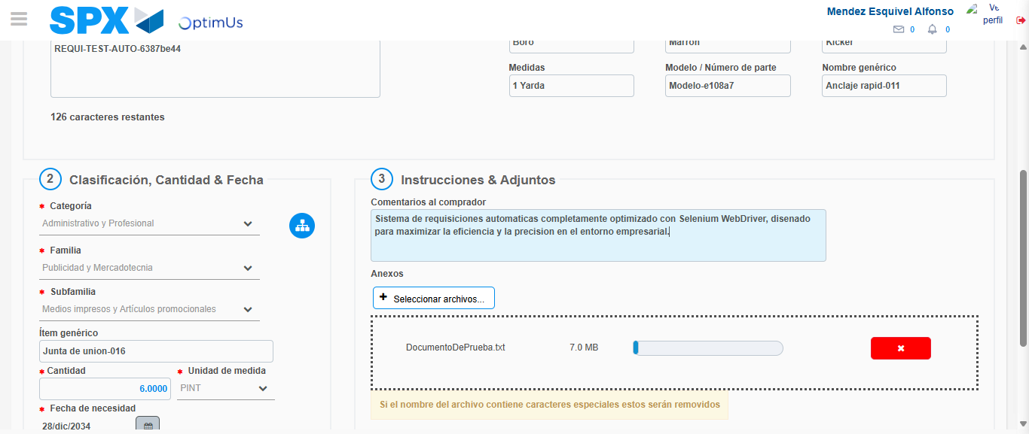Image file-name: QC_Testing-tc002_SPX_Dev5_Crear_Requisicion_Spot_Tipo_Cobro_Project-1784307338519

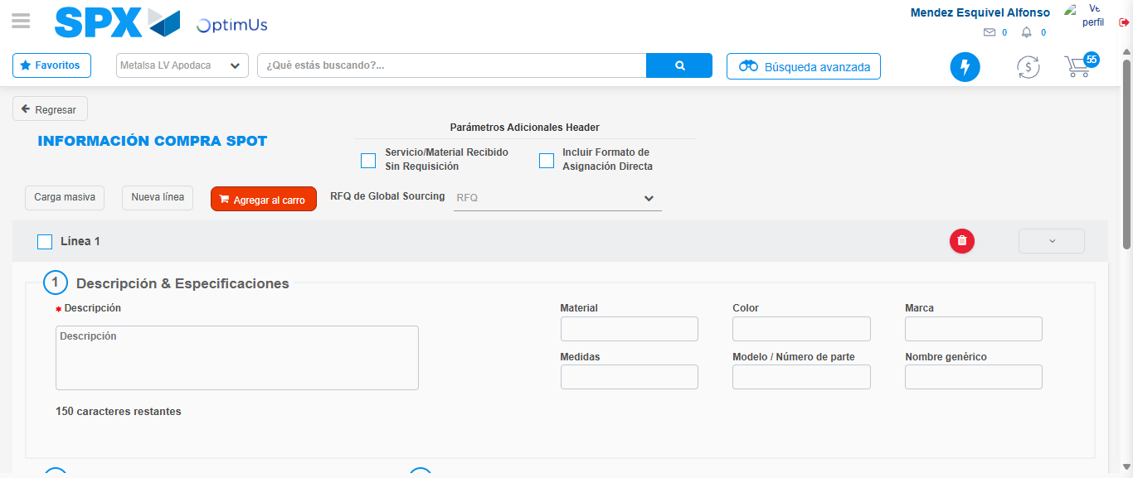Image file-name: QC_Testing-tc002_SPX_Dev5_Crear_Requisicion_Spot_Tipo_Cobro_Project-1784307349491

Step 7 - Return to Main Page SPX : Return to Main Page SPX
Image file-name: QC_Testing-tc002_SPX_Dev5_Crear_Requisicion_Spot_Tipo_Cobro_Project-1784307312646

Image file-name: QC_Testing-tc002_SPX_Dev5_Crear_Requisicion_Spot_Tipo_Cobro_Project-1784307315125

Image file-name: QC_Testing-tc002_SPX_Dev5_Crear_Requisicion_Spot_Tipo_Cobro_Project-1784307326531

Image file-name: QC_Testing-tc002_SPX_Dev5_Crear_Requisicion_Spot_Tipo_Cobro_Project-1784307351738

Image file-name: QC_Testing-tc002_SPX_Dev5_Crear_Requisicion_Spot_Tipo_Cobro_Project-1784307351905

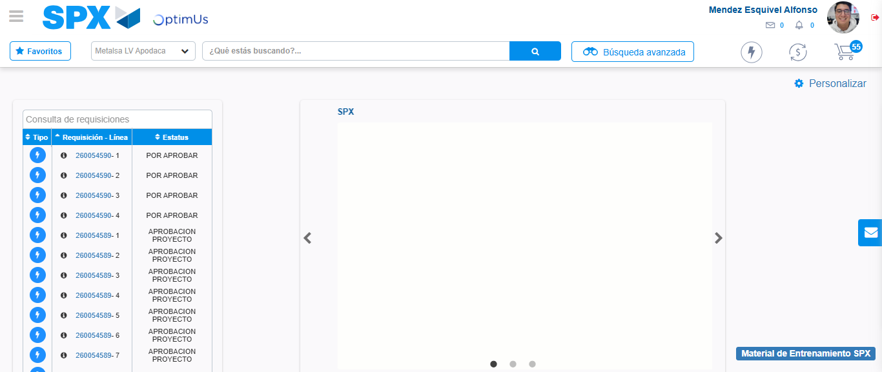Image file-name: QC_Testing-tc002_SPX_Dev5_Crear_Requisicion_Spot_Tipo_Cobro_Project-1784307372905

Step 8 - Log Out : Log Out SPX
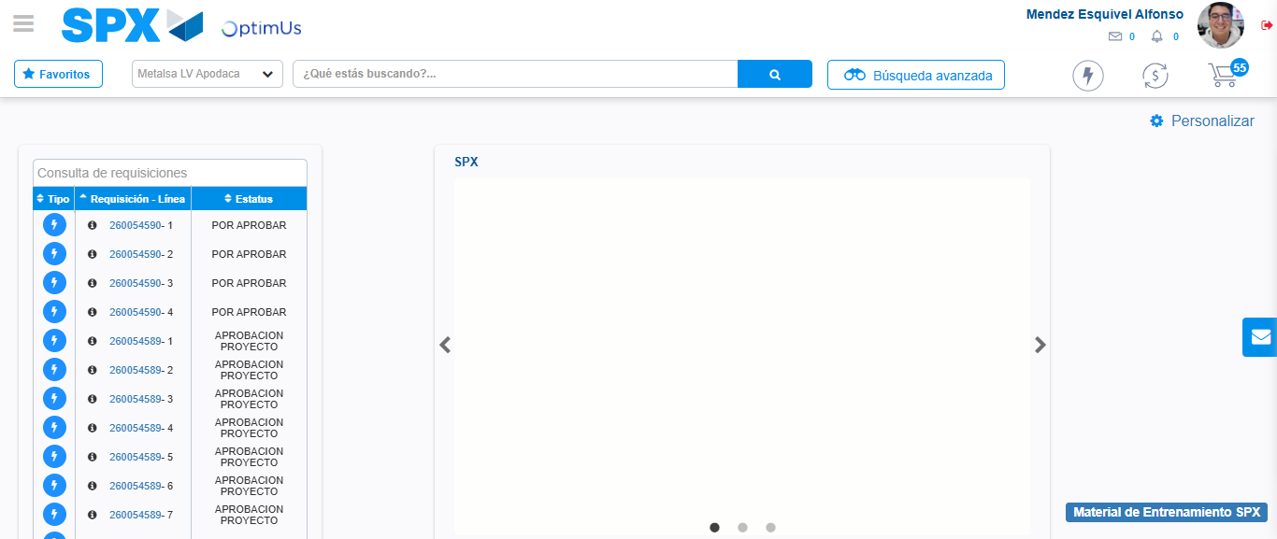Image file-name: QC_Testing-tc002_SPX_Dev5_Crear_Requisicion_Spot_Tipo_Cobro_Project-1784307373118

